🛠️ THE SCULPT
Presented by Toyrat Enterprises
A cinematic gameshow transforming 2D character concepts into 3D digital models.
Each episode features a new independent IP and a sculptor showdown across three competitive phases.
🎬 WHAT IS THE SCULPT?
The Sculpt is a high-stakes competition hosted by Toyrat Enterprises, where up to 10 sculptors battle to bring a 2D character to life in 3D. Contestants interpret reference material, build digital models, and compete for cash, exposure, and the chance to beat Toyrat’s own sculpt.
📜 GENERAL RULES
🧾 APPLICATION REQUIREMENTS
All contestants must submit:
- Full name and location
- Languages spoken
- Medium used (software and/or physical)
- Clear headshot for the website
- Short bio (max 250 words)
- Up to 2 links to previous work or contact info
- “Cocky Statement” explaining how they plan to win
- Years of experience
- Freelance or company affiliation
- Typical pricing for commissioned work
🌀 PHASE 1: CONCEPT & PITCH
🔹 Overview
- Up to 10 sculptors selected per episode
- All receive identical reference material via Google Drive
- Includes a short video from the IP owner explaining their vision
- Sculptors interpret the material and choose a pose
🔹 Deliverables
- Initial concept presentation (sketch, layout, or render)
- Must reflect the sculptor’s intended final direction
🔹 Judging
- Judges select top 5 sculptors to advance
- Remaining 5 are thanked and invited to return in future episodes
🧱 PHASE 2: BUILD & INTERVIEW
🔹 Timeline
- 10 days to complete this phase (20 days total into competition)
🔹 Requirements
- Video footage of sculpting process
- Upload assets to designated Google Drive folder
- 10-minute interview with The Sculpt team
- Edited for episode
- Full version hosted on contestant’s page
🔹 Contestant Page
- Bio, headshot, links, and interview hosted until elimination
🔹 Deliverables
- Fully fleshed, print-ready 3D model
- STL file for review
- 3 PNG renders with transparent backgrounds (front and opposing sides)
🔹 Judging
- Judges select 3 finalists to advance
🖨️ PHASE 3: PRINT & FINISH
🔹 Process
- Finalists’ models printed and finished on camera
- Sculptors may specify color and style preferences
- Option to provide their own printed model (must arrive by deadline)
🔹 Review
- Judges receive physical models for 1-day evaluation
- Final review includes IP owner as tie-breaker
🏆 FINAL SHOWDOWN: BEAT THE BEST
🔹 Challenge
- Finalist’s model is compared to Toyrat Enterprises’ version of the same character
🔹 Judging Panel
- Canon Doll X – Host, entertainer
Natasha Stagmer – Personality
- Miguel Figueroa – ToyQuest 101
- Rocco Tartamella – Renowned sculptor
- Previous episode winner or Ricardo Diaz Marrera (if winner is competing)
Ricardo Diaz Marrera is excluded from the final “Beat the Best” vote.
💰 PRIZES
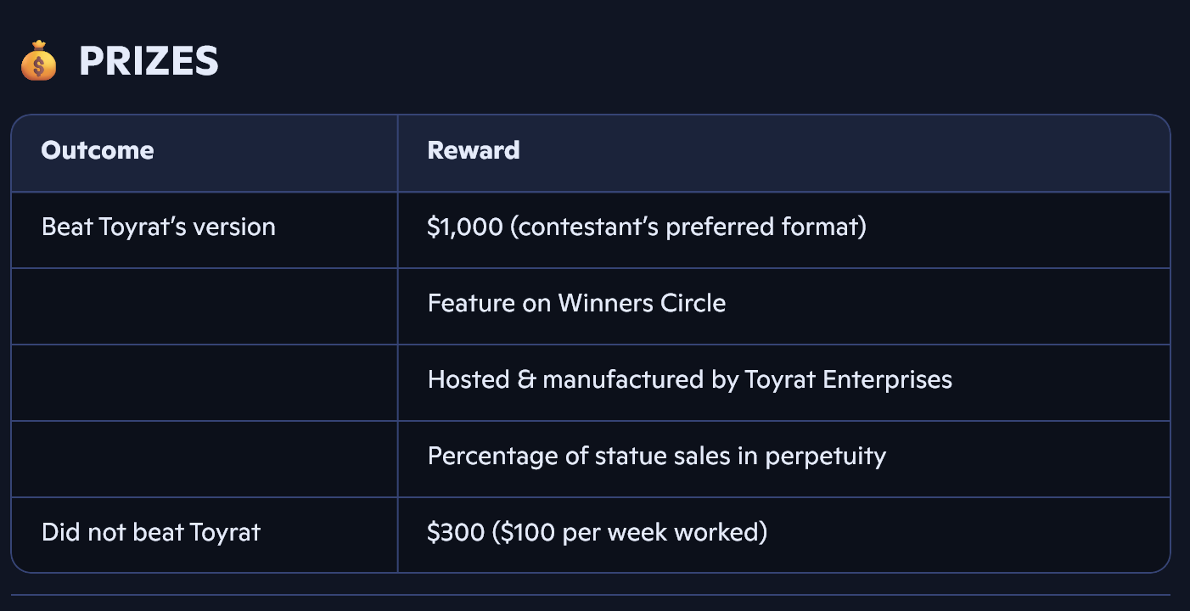
📺 BROADCAST & PROMOTION
- Episodes air ~2 weeks after final takes
- Distributed via Toyrat website, YouTube, TikTok, and other platforms

